**Name: Gaurav Kumar Singh**

**Registration Number:19BCE2119**

**Course: Web Technology**

**Lab FAT**

Create a database which will store the Book information which includes the following:  
  
1) Title of the book  
  
2) Author Name  
  
3) ISBN number  
  
4) Publisher name  
  
5) Edition  
  
6) Price  
  
Create a web page with all the above fields for inserting data into the database when a button is clicked. Also validate the fields wherever required. Use a simple styling.

**CODE:**

**Index.js**

var express = require("express");

var bodyParser = require("body-parser");

const mongoose = require('mongoose');

mongoose.connect('mongodb://localhost:27017/LabFAT', {

    useNewUrlParser: true

});

var app = express()

app.use(bodyParser.json());

app.use(express.static('public'));

app.use(bodyParser.urlencoded({

    extended: true

}));

const books = new mongoose.Schema({

    Title: String,

    Author: String,

    ISBN: Number,

    Publisher: String,

    Edition: String,

    Price: Number

});

const Books = mongoose.model("books", books);

app.get("/", function (req, res) {

    res.sendFile(__dirname + "/LabFAT.html")

})

app.get("/addbook", function (req, res) {

    var title = req.query.ti;

    var author = req.query.au;

    var isbn = req.query.is;

    var publisher = req.query.pu;

    var edition = req.query.ed;

    var price = req.query.pr;

    console.log(title)

    console.log(author)

    console.log(isbn)

    console.log(publisher)

    console.log(edition)

    console.log(price)

    stringreg = /\w+/;

    ISBNreg = /^(?=(?:\D*\d){10}(?:(?:\D*\d){3})?$)[\d-]+$/

    pricereg = /\d/

    var flag=0;

    if (stringreg.test(title) && stringreg.test(author) && stringreg.test(publisher) && stringreg.test(edition) && ISBNreg.test(isbn) && pricereg.test(price)) {

        Books.insertMany([{

            Title: title,

            Author: author,

            ISBN: isbn,

            Publisher: publisher,

            Edition: edition,

            Price: price

        }], function (err, result) {

            if (err) {

                res.end(err);

            } else {

                res.end(JSON.stringify(result));

            }

        })

    } else{

        res.end("Enter Valid Data");

    }

})

app.listen(3000, function () {

    console.log("Server Started");

})

**LabFAT.html**

<!DOCTYPE html>

<html lang="en">

<head>

    <meta charset="UTF-8">

    <meta http-equiv="X-UA-Compatible" content="IE=edge">

    <meta name="viewport" content="width=device-width, initial-scale=1.0">

    <title>Document</title>

    <style>

        form{

            margin: 0 auto;

        }

        table tr td:nth-child(1){

            text-align:right

        }

        table tr{

            height:40px;

        }

    </style>

</head>

<body>

    <form action="/addbook" method=get style="width:fit-content">

        <fieldset>

            <legend><b>Add Book</b></legend>

            <table>

                <tr><td>Title:</td><td><input type=text name=ti required placeholder=BookName></td></tr>

                <tr><td>Author:</td><td><input type=text name=au required placeholder=Author></td></tr>

                <tr><td>ISBN no:</td><td><input type=number name=is required placeholder=1234567890></td></tr>

                <tr><td>Publisher:</td><td><input type=text name=pu required placeholder=Publisher></td></tr>

                <tr><td>Edition:</td><td><input type=text name=ed required placeholder=Edition></td></tr>

                <tr><td>Price:</td><td><input  name=pr required ></td></tr>

            </table>

            <input type=submit>&nbsp;&nbsp;<input type=reset><br>

        </fieldset>

    </form>

</body>

</html>

**SCREENSHOTS**

**ADDING DATA THROUGH MONGO TERMINAL**

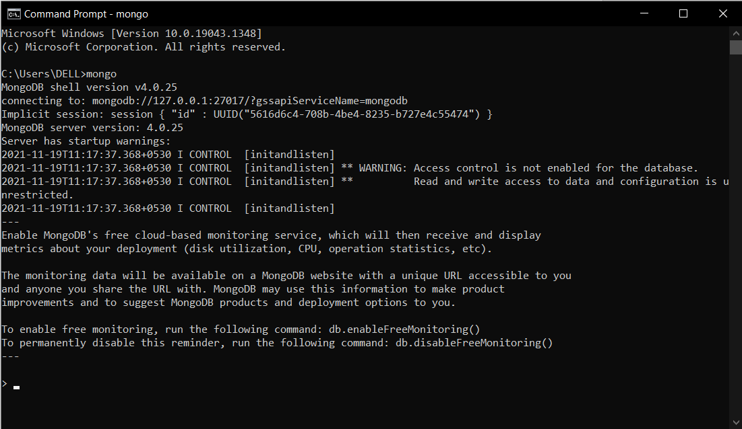

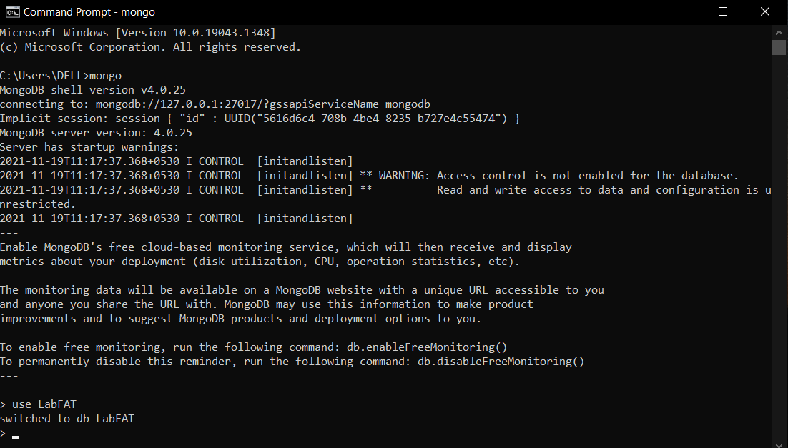

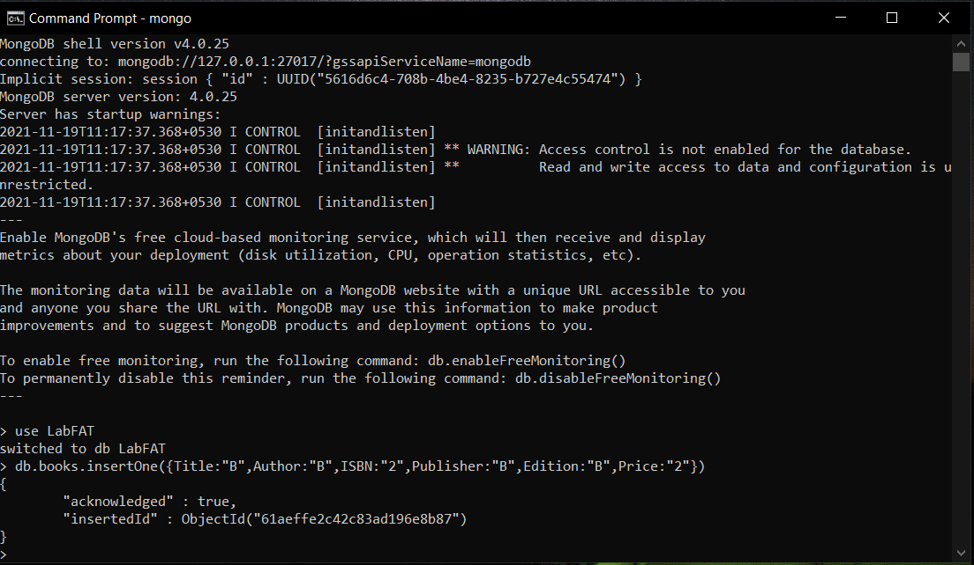

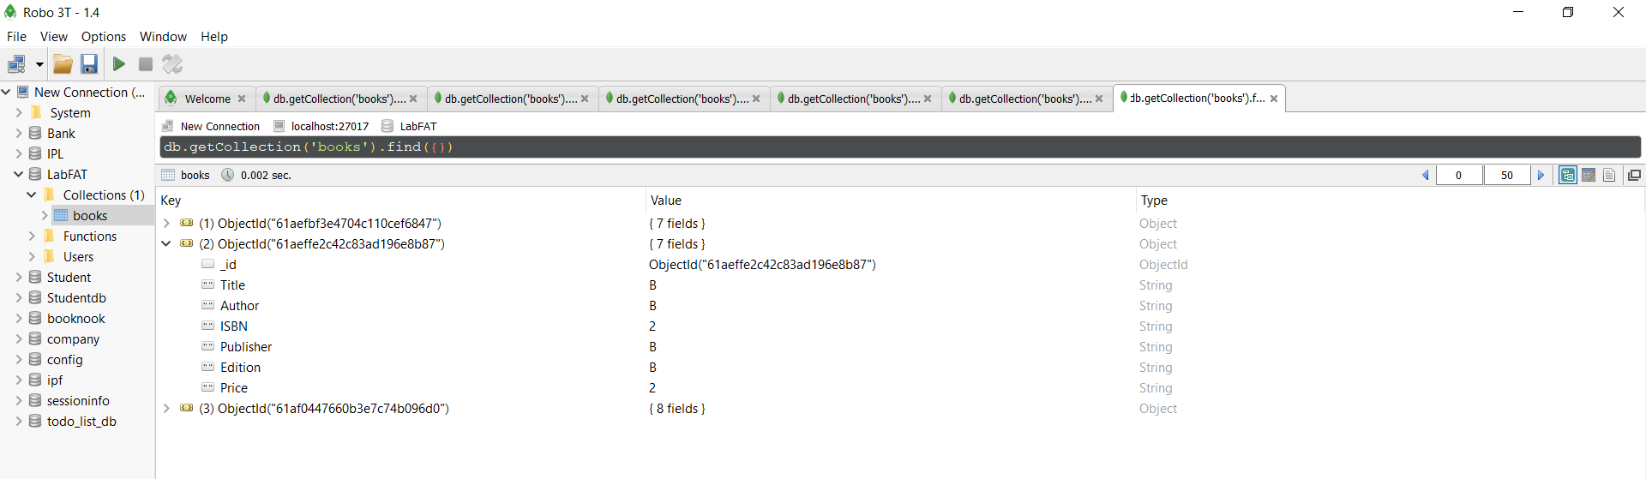

**ADDING DATA THROUGH WEBPAGE USING EXPRESS NODE.JS AND MONGOOSE**

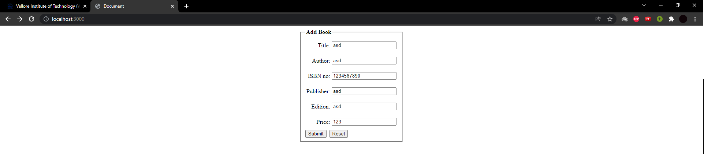

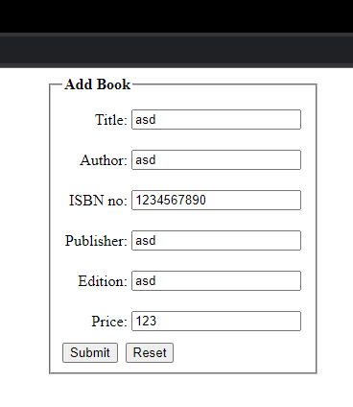

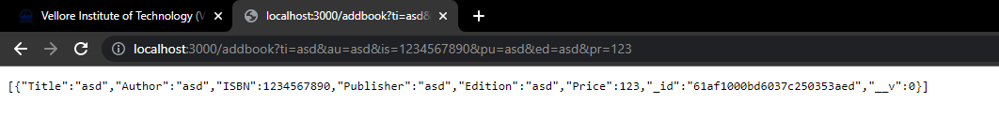

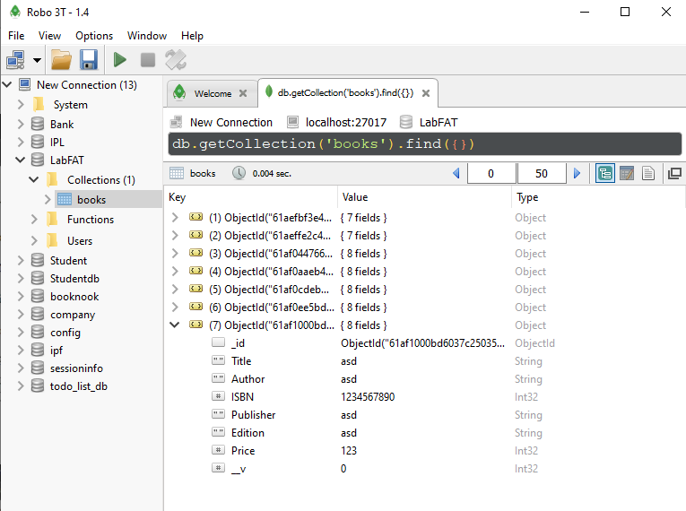

**CODE SCREENSHOT**

